African Violet Pot Catalog

 |       P.O. Box 220114  Chantilly, VA 20153  Tel: 1-800-214-9525 Pin #22  www.violetpots.com | 

Arts & Crafts by Eloisa Catalog

African Violet Pot Colors

Solid Color
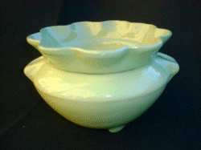  Tiffany Green | 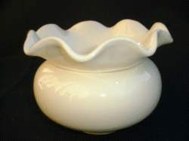  Ivory | 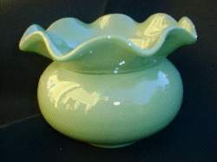  Jade Mist
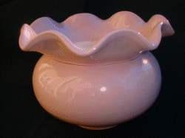  Mauve | 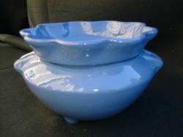  Militia Blue | 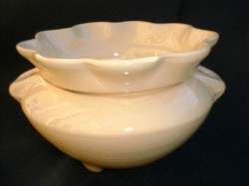  Oriental Beige
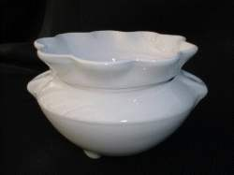  Pure White | 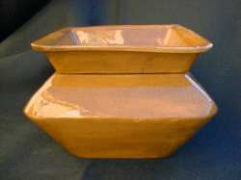  Speckled Brown

 | Crystal Glaze
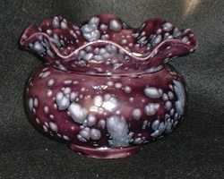  Purple Splash | 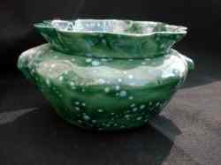  Emerald Forest | 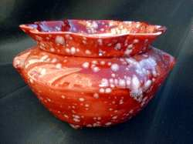  Ruby Sensation
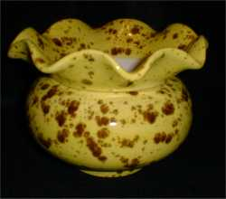  Banana Boat | 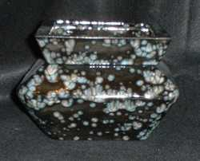  Black Odessy | 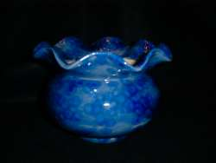  Wild Blue Yonder
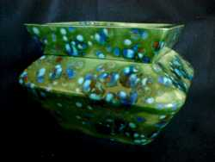  Peacock | 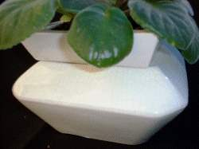  Cracked Pot | 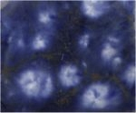  Shooting Stars

 | Floral Design
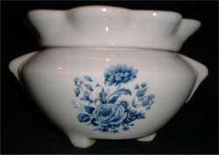  Floral 1 | 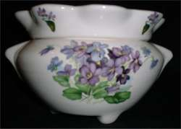  Floral 2 | 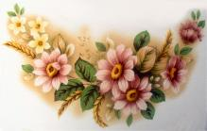  Floral 3
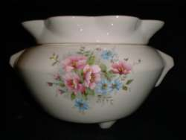  Floral 4 |   Floral 5

African Violet Pot Styles
(Prices do not include shipping/handling)

Style #1  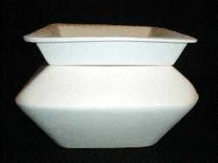  Large square 7 3/4" x 5 3/8" high  Solid Color: $20.75  Crystal Glaze: $22.00  Floral Design: $22.50  </div> | Style #2  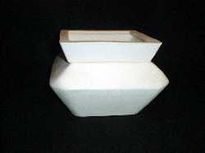  Medium square 6 3/4" x 4 1/2" high  Solid Color: $17.25  Crystal Glaze: $18.50  Floral Design: $19.00</div>
Style #3  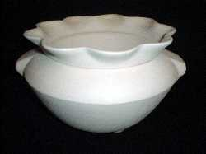  Large fluted 7 3/4" diam x 4 3/4" high  Solid Color: $20.75  Crystal Glaze: $22.00  Floral Design: $22.50  </div> | Style #4  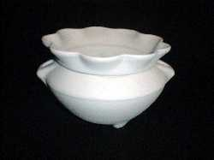  Medium fluted 5 1/2" diam x 4" high  Solid Color: $17.25  Crystal Glaze: $18.50  Floral Design: $19.70  </div> | Style #5  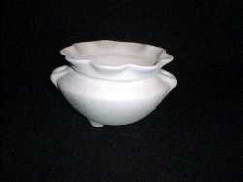  Small fluted 4 3/4" diam x 3 1/8" high  Solid Color: $12.70  Crystal Glaze: $13.95  </div>
 | Style #6  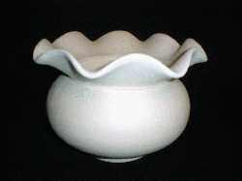  Medium ruffled 5 7/8" diam x 4 3/4" high  Solid Color: $17.25  Crystal Glaze: $18.50  Floral Design: $19.00  </div> | Style #7  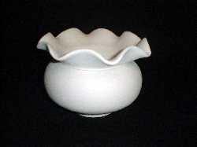  Small ruffled 5" diam x 4 1/8" high  Solid Color: $12.70  Crystal Glaze: $13.95</div>

African Violet Pot Order Form

Send Money Order/Check to:
Eloisa Wilson
P.O. Box 220114
Chantilly, Va 20153

Shipping Information:

Name: | _______________________________________
Address: | ____________________  ____________________  ____________________
City: | ____________________
State: | ___
Zip Code: | _______
Telephone #: | ____________________
E-Mail: | ____________________
Order Total: | _________________

Item |  | Qty | Total
Style #1 (Large)
Solid Color | Price ea $20.75 + $6.40 per pot S/H Total ea: $27.15
[] Ivory
[] Jade Mist
[] Mauve
[] Militia Blue
[] Oriental Biege
[] Pure White
[] Speckle Brown
[] Tiffany Green
Style #1 (Large)
Crystal Glaze | Price ea.: $22.00 + $6.40 per pot S/H Total ea: $28.40
[] Purple Splash
[] Ruby Sensation
[] Cracked Pot
[] Black Odessy
[] Emerald Forest
[] Shooting Stars
[] Banana Boat
[] Wild Blue Yonder
[] Peacock
Style #1 (Large)
Floral | Price ea.: $22.50 + $6.40 per pot S/H Total ea: $28.90
[] Floral #1
[] Floral #2
[] Floral #3
[] Floral #4
[] Floral #5

Item |  | Qty | Total
Style #2 (Medium)
Solid Color | Price ea.: $17.25 + $6.40 per pot S/H Total ea: $23.65
[] Ivory
[] Jade Mist
[] Mauve
[] Militia Blue
[] Oriental Biege
[] Pure White
[] Speckle Brown
[] Tiffany Green
Style #2 (Medium)
Crystal Glaze | Price ea.: $18.50 + $6.40 per pot S/H Total ea: $24.90
[] Purple Splash
[] Ruby Sensation
[] Cracked Pot
[] Black Odessy
[] Emerald Forest
[] Shooting Stars
[] Banana Boat
[] Wild Blue Yonder
[] Peacock
Style #2 (Medium)
Floral | Price ea.: $19.00 + $6.40 per pot S/H Total ea: $25.40
[] Floral #1
[] Floral #2
[] Floral #3
[] Floral #4
[] Floral #5
Style #3 (Large)
Solid Color | Price ea $20.75 + $6.40 per pot S/H Total ea: $27.15
[] Ivory
[] Jade Mist
[] Mauve
[] Militia Blue
[] Oriental Biege
[] Pure White
[] Speckle Brown
[] Tiffany Green
Style #3 (Large)
Crystal Glaze | Price ea.: $22.00 + $6.40 per pot S/H Total ea: $28.40
[] Purple Splash
[] Ruby Sensation
[] Cracked Pot
[] Black Odessy
[] Emerald Forest
[] Shooting Stars
[] Banana Boat
[] Wild Blue Yonder
[] Peacock

Item |  | Qty | Total
Style #3 (Large)
Floral | Price ea.: $22.50 + $6.40 per pot S/H Total ea: $28.90
[] Floral #1
[] Floral #2
[] Floral #3
[] Floral #4
[] Floral #5
Style #4 (Medium)
Solid Color | Price ea.: $17.25 + $6.40 per pot S/H Total ea: $23.65
[] Ivory
[] Jade Mist
[] Mauve
[] Militia Blue
[] Oriental Biege
[] Pure White
[] Speckle Brown
[] Tiffany Green
Style #4 (Medium)
Crystal Glaze | Price ea.: $18.50 + $6.40 per pot S/H Total ea: $24.90
[] Purple Splash
[] Ruby Sensation
[] Cracked Pot
[] Black Odessy
[] Emerald Forest
[] Shooting Stars
[] Banana Boat
[] Wild Blue Yonder
[] Peacock
Style #4 (Medium)
Floral | Price ea.: $19.00 + $6.40 per pot S/H Total ea: $25.40
[] Floral #1
[] Floral #2
[] Floral #3
[] Floral #4
[] Floral #5

Item |  | Qty | Total
Style #5 (Small)
Solid Color | Price ea.: $12.70 + $6.40 per pot S/H Total ea: $19.10
[] Ivory
[] Jade Mist
[] Mauve
[] Militia Blue
[] Oriental Biege
[] Pure White
[] Speckle Brown
[] Tiffany Green
Style #5 (Small)
Crystal Glaze | Price ea.: $13.95 + $6.40 per pot S/H Total ea: $20.35
[] Purple Splash
[] Ruby Sensation
[] Cracked Pot
[] Black Odessy
[] Emerald Forest
[] Shooting Stars
[] Banana Boat
[] Wild Blue Yonder
[] Peacock
Style #6 (Medium)
Solid Color | Price ea.: $17.25 + $6.40 per pot S/H Total ea: $23.65
[] Ivory
[] Jade Mist
[] Mauve
[] Militia Blue
[] Oriental Biege
[] Pure White
[] Speckle Brown
[] Tiffany Green
Style #6 (Medium) | Price ea.: $18.50 + $6.40 per pot S/H Total ea: $24.90
Crystal Glaze
[] Purple Splash
[] Ruby Sensation
[] Cracked Pot
[] Black Odessy
[] Emerald Forest
[] Shooting Stars
[] Banana Boat
[] Wild Blue Yonder
[] Peacock
Style #6 (Medium) | Price ea.: $19.00 + $6.40 per pot S/H Total ea: $25.40
Floral
[] Floral #1
[] Floral #2
[] Floral #3
[] Floral #4
[] Floral #5

Item |  | Qty | Total
Style #7 (Small) | Price ea.: $12.70 + $6.40 per pot S/H Total ea: $19.10
Solid Color
[] Ivory
[] Jade Mist
[] Mauve
[] Militia Blue
[] Oriental Biege
[] Pure White
[] Speckle Brown
[] Tiffany Green
Style #7 (Small) | Price ea.: $13.95 + $6.40 per pot S/H Total ea: $20.35
Crystal Glaze
[] Purple Splash
[] Ruby Sensation
[] Cracked Pot
[] Black Odessy
[] Emerald Forest
[] Shooting Stars
[] Banana Boat
[] Wild Blue Yonder
[] Peacock

